Consulting, Training & Auditing
Your Partner for Improvement and Compliance Since 1996

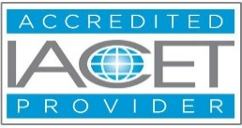

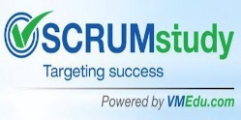

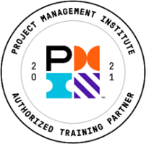
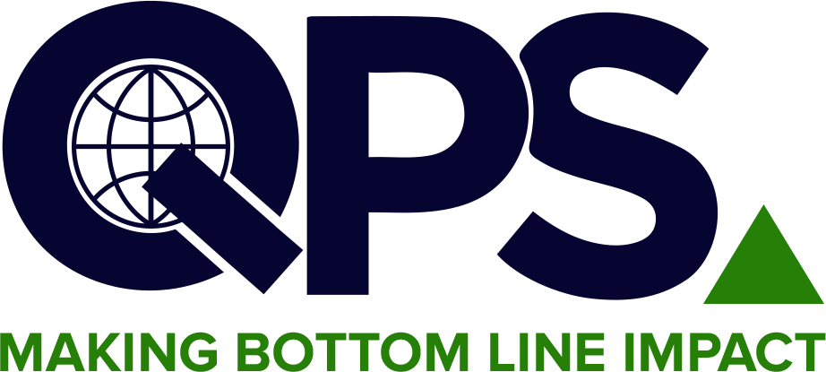
Quality & Productivity Solutions, Inc.
Most diversified offering of over 400 courses
linkedin.com/company/2070049/admin/feed/posts/ https://www.facebook.com/TheQPSInstitute https://twitter.com/TheQPSInstitute
Email: training@qpsinc.com, jayp@qpsinc.com
Website: www.qpsinc.com Phone: (508) 786-0777

Transitioning to ISO 9001:2026 & Auditing (Understanding, documenting & auditing to ISO 19011:2026)
Course No. 100A

🗓  Duration  14 Hours ( 2 days) | 📚  Modules  6 Modules | 🏢  Format  Instructor-driven via Zoom | 🎓  Outcome  QPS Certificate for transitioning & auditing

COURSE OVERVIEW

ISO 9001:2026 is the latest revision of the world's most widely adopted Quality Management System (QMS) standard. This course is designed to help organizations and professionals understand what has changed from ISO 9001:2015 and how to transition their QMS effectively to meet the updated requirements. Also included how to document, SOP examples, how to audit using ISO 19011:2026, Auditing Management System.
Participants will gain the skills to assess their current QMS against the new requirements, identify gaps, and implement changes to maintain certification and drive ongoing quality improvement. This is for experienced auditors, for new auditors, 3 day class is suggested.

LEARNING OUTCOMES & KEY TAKEAWAYS

Upon completion of this course, participants will be able to:
- Understand the key changes and enhancements introduced in ISO 9001:2026 versus ISO 9001:2015
- Identify the impact of the 2026 revision on existing QMS documentation and processes
- How to document changes by reviwing sample SOPs
- Assess organizational readiness and develop a transition plan
- Align QMS updates with the revised risk-based thinking and leadership requirements including developing opportunity register.
- Understand the updated requirements for interested parties, context of the organization, and digital transformation
- How to audit ( in person and remote) using ISO 19001:2026
- Conduct remote auditing workshop
- Prepare for re-certification and manage the transition audit process
- Foster a quality-first culture aligned with the 2026 revision objectives

COURSE CURRICULUM

Module | Title | Key Topics Covered
MODULE 1 | Introduction to ISO 9001:2026 & Key Changes | Overview of the 2026 revision, comparison with 2015, structure, scope, and key drivers of change
MODULE 2 | Context, Leadership & Risk-Based Thinking | Updated requirements for organizational context, interested parties, leadership accountability, and enhanced risk-based thinking
MODULE 3 | QMS Planning, Support & Operations | Planning changes, resource management, operational controls, and documented information updates in 2026
MODULE 4 | Performance Evaluation, Transition & Certification | Monitoring, measurement, internal audit, management review, corrective action, and transition to ISO 9001:2026 certification
MODULE 5 | How to document & review SOPs | Documented information, review of changed 8 new/changed SOPs & Forms
MODULE 6 | How to audit using ISO 19011:2026 | Learn how to audit, process, risk & opportunity based auditing, remote and onsite

COURSE INSTRUCTOR

The seminar leader will be an Certified ISO 9001:2026 Lead Auditor and Lead Implementer with experience in implementing ISO 9001 and other management systems.

WHO SHOULD ATTEND

Quality & Management Professionals  - Quality managers and QMS coordinators  - Internal auditors and compliance officers  - Top management and department heads  - Professionals responsible for QMS maintenance  - Organizations currently certified to ISO 9001:2015 | Operations & Business Teams  - Line managers and supervisors  - Process owners and improvement teams  - Suppliers and contractors seeking transition guidance  - Onboarding staff requiring 2026 awareness/training  - Anyone involved in QMS

FOR FURTHER INFORMATION

Contact our Operations Manager via the email address given below!
📧 training@qpsinc.com 🌐 www.qpsinc.com

