Consulting, Training & Auditing
Your Partner for Improvement and Compliance Since 1996

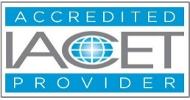

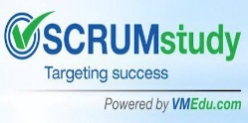

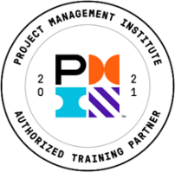
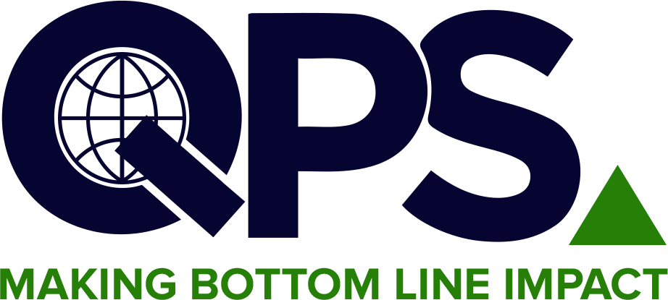
Quality & Productivity Solutions, Inc.
Most diversified offering of over 400 courses
linkedin.com/company/2070049/admin/feed/posts/ https://www.facebook.com/TheQPSInstitute https://twitter.com/TheQPSInstitute
Email: training@qpsinc.com, jayp@qpsinc.com
Website: www.qpsinc.com Phone: (508) 786-0777

Process Mapping & Process Management using AI
Course No. 102B

🗓  Duration  7 Hours | 📚  Modules  4 Modules | 🏢  Format  Instructor-driven via Zoom | 🎓  Outcome  QPS Certificate

COURSE OVERVIEW

This course has been designed to help participants understand the process approach, concepts, and how to map and manage processes using AI-powered tools. In most management standards, a process approach is required and is an effective way to design and deploy a Management System.
Participants will learn how to leverage AI tools to accelerate process mapping, generate process documentation, identify improvement opportunities, and automate workflow documentation — combining traditional process management best practices with modern AI capabilities.

LEARNING OUTCOMES & KEY TAKEAWAYS

Upon completion of this course, participants will be able to:
- Understand process concepts, metrics, and the process approach in management systems
- Develop flow charts and process maps from scratch or from existing documents
- Map Level II and Level III processes using process mapping techniques
- Leverage AI tools to accelerate process documentation and mapping
- Improve QMS documentation quality and usability using AI-assisted methods
- Apply process redesign and optimization techniques
- Understand process governance, lifecycle, and automation transformation

COURSE CURRICULUM

Module | Title | Key Topics Covered
MODULE 1 | Introduction to Process Management & Mapping | Process concepts and metrics, process approach in management systems, flow charts vs. process maps
MODULE 2 | Developing Process Maps (Level II & III) | Step-by-step process mapping, Level II and III mapping exercises, converting documents to process maps
MODULE 3 | AI Tools for Process Mapping & Documentation | AI-powered process mapping tools, generating process documentation using AI, automation of workflows
MODULE 4 | Process Improvement, Redesign & Governance | Process analysis and improvement techniques, process redesign, optimization, governance, and lifecycle management

COURSE INSTRUCTOR

The seminar leader will be an ASQ Certified Quality Auditor and ASQ Certified Black Belt with 20+ years experience in implementing these methodologies.

WHO SHOULD ATTEND

Quality & Operations Professionals  - Quality managers and process owners  - QMS coordinators and document controllers  - Operations and manufacturing managers  - Business analysts and process improvement professionals  - Anyone reducing and simplifying documentation | Technical & Business Teams  - IT professionals supporting QMS systems  - Project managers mapping workflows  - AI-curious professionals in quality roles  - Internal auditors reviewing process documentation  - Anyone interested in AI applications in process management

FOR FURTHER INFORMATION

Contact our Operations Manager via the email address given below!
📧 training@qpsinc.com 🌐 www.qpsinc.com

