Consulting, Training & Auditing
Your Partner for Improvement and Compliance Since 1996

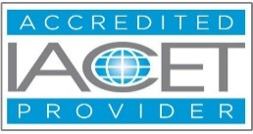



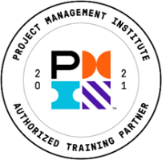
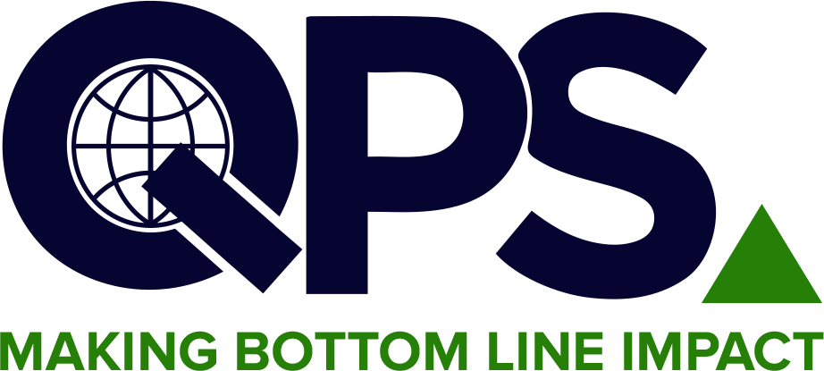
Quality & Productivity Solutions, Inc.
Most diversified offering of over 400 courses
linkedin.com/company/2070049/admin/feed/posts/ https://www.facebook.com/TheQPSInstitute https://twitter.com/TheQPSInstitute
Email: training@qpsinc.com, jayp@qpsinc.com
Website: www.qpsinc.com Phone: (508) 786-0777

Internal Auditing to ISO 14001:2026
Course No. 103B

🗓  Duration  21 Hours | 📚  Modules  7 Modules | 🏢  Format  Instructor-driven via Zoom | 🎓  Outcome  QPS Certificate

COURSE OVERVIEW

This course provides a thorough understanding of internal auditing practices aligned with ISO 14001:2026 — the latest revision of the international EMS standard. Participants will learn to evaluate EMS compliance, identify improvement opportunities, and contribute to environmental performance under the updated requirements.
The course incorporates hands-on audit exercises, checklist development, and real-world scenarios reflecting the 2026 revisions including climate change integration, digital sustainability reporting, and enhanced stakeholder obligations.

LEARNING OUTCOMES & KEY TAKEAWAYS

Upon completion of this course, participants will be able to:
- Understand the updated requirements of ISO 14001:2026 and key changes from the 2015 version
- Identify environmental aspects, impacts, and compliance obligations under the 2026 revision
- Understand the role and responsibilities of an internal EMS auditor
- Plan and prepare for an effective internal EMS audit
- Conduct a thorough internal audit and gather objective evidence
- Report audit findings clearly and accurately
- Follow up on corrective actions and contribute to continual improvement

COURSE CURRICULUM

Module | Title | Key Topics Covered
MODULE 1 | Overview of ISO 14001:2026 & Key Changes | EMS overview, ISO 14001:2026 structure, key changes from 2015, climate change and circular economy additions
MODULE 2 | Environmental Aspects, Impacts & Compliance Obligations | Identifying and evaluating aspects and impacts, compliance obligations register, legal requirements
MODULE 3 | Leadership, Planning & Risk-Based Thinking | Leadership responsibilities, environmental policy, objectives, risk-based thinking under 2026 revision
MODULE 4 | Support, Operations & Emergency Preparedness | Competence and awareness, documented information, operational controls, emergency preparedness and response
MODULE 5 | Internal Audit Planning & Preparation | Internal audit principles, developing audit plans, checklists, tools, and pre-audit documentation
MODULE 6 | Conducting the Internal Audit | Opening meeting, evidence gathering techniques, interviewing, audit trail, managing the audit
MODULE 7 | Reporting, Follow-Up & Auditor Competence | Writing findings and nonconformities, audit report, corrective action follow-up, auditor roles and competencies

COURSE INSTRUCTOR

The seminar leader is an Expert Certified Lead Auditor with over 20 years' experience in implementing ISO 14001 and other environmental management systems.

WHO SHOULD ATTEND

Environmental & Audit Professionals  - EMS internal auditors  - Environmental and sustainability professionals  - Quality, health, and safety personnel  - Compliance officers and operations managers  - Individuals preparing for ISO 14001:2026 certification | Management & Technical Teams  - Facility managers and sustainability leads  - Consultants and advisors in EMS  - Process owners with environmental responsibilities  - Anyone with basic ISO 14001 background  - Professionals advancing their EMS audit competency

FOR FURTHER INFORMATION

Contact our Operations Manager via the email address given below!
📧 training@qpsinc.com 🌐 www.qpsinc.com

