Consulting, Training & Auditing
Your Partner for Improvement and Compliance Since 1996

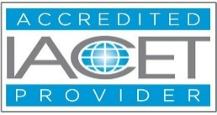



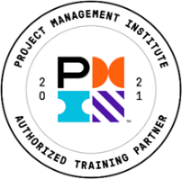
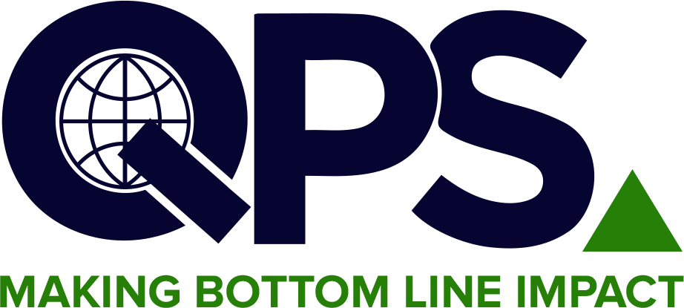
Quality & Productivity Solutions, Inc.
Most diversified offering of over 400 courses
linkedin.com/company/2070049/admin/feed/posts/ https://www.facebook.com/TheQPSInstitute https://twitter.com/TheQPSInstitute
Email: training@qpsinc.com, jayp@qpsinc.com
Website: www.qpsinc.com Phone: (508) 786-0777

QMS Internal Auditor for ISO 9001:2026
Course No. 105B

🗓  Duration  21 Hours | 📚  Modules  7 Modules | 🏢  Format  Instructor-driven via Zoom | 🎓  Outcome  QPS Certificate

COURSE OVERVIEW

This course teaches participants how to plan, conduct, and follow up on Quality Management System internal audits aligned with ISO 9001:2026 — the latest revision of the international quality standard. Participants learn the updated standard requirements, auditing best practices, and ISO 19011 guidelines.
The course emphasizes leadership accountability, risk-based auditing, and the updated interested party and context requirements introduced in ISO 9001:2026. Participants gain practical skills through formal coursework, role-playing, and group workshops.

LEARNING OUTCOMES & KEY TAKEAWAYS

Upon completion of this course, participants will be able to:
- Understand the purpose and structure of ISO 9001:2026 and the ISO 9000 family
- Interpret each clause of ISO 9001:2026 and understand updated requirements
- Apply the seven quality management principles in an audit context
- Identify audit evidence needed to demonstrate conformity to ISO 9001:2026
- Evaluate QMS effectiveness including process approach and continual improvement
- Plan, perform, report, and follow up on internal QMS audits
- Describe the roles and responsibilities of auditors and auditees at all stages

COURSE CURRICULUM

Module | Title | Key Topics Covered
MODULE 1 | Introduction & ISO 9001:2026 Requirements | QMS background, ISO 9001:2026 structure, key changes from 2015, terminology and definitions
MODULE 2 | Context, Leadership & Risk-Based Thinking | Organizational context, interested parties, leadership, planning, and updated risk-based thinking
MODULE 3 | Support, Operations & Documented Information | Competence, communication, documented information, operational planning and control
MODULE 4 | Performance Evaluation, Improvement & Corrective Action | Monitoring, measurement, internal audit, management review, nonconformity, corrective action
MODULE 5 | ISO 19011 & Pre-Audit Activities | ISO 19011 guidelines, audit types, pre-audit planning, checklist development, audit scheduling
MODULE 6 | Conducting the Internal Audit | On-site audit activities, evidence gathering, interviewing, nonconformance identification
MODULE 7 | Audit Reporting, Follow-Up & Continual Improvement | Audit reporting, nonconformance writing, corrective action follow-up, and improvement culture

COURSE INSTRUCTOR

The course instructor will be a Certified Lead Auditor with 10+ years' experience in implementing and training ISO 9001:2026 and other QMS methodologies.

WHO SHOULD ATTEND

Audit & Quality Professionals  - First, second, and third-party auditors  - Quality managers and compliance officers  - QMS coordinators and document controllers  - Professionals leading ISO 9001:2026 compliance  - Supply chain and supplier quality assurance staff | Operations & Business Teams  - Internal audit team members  - Managers broadening their audit knowledge  - Corporate auditors expanding QMS knowledge  - Anyone transitioning from ISO 9001:2015 to 2026  - Professionals in supply chain management or quality control

FOR FURTHER INFORMATION

Contact our Operations Manager via the email address given below!
📧 training@qpsinc.com 🌐 www.qpsinc.com

